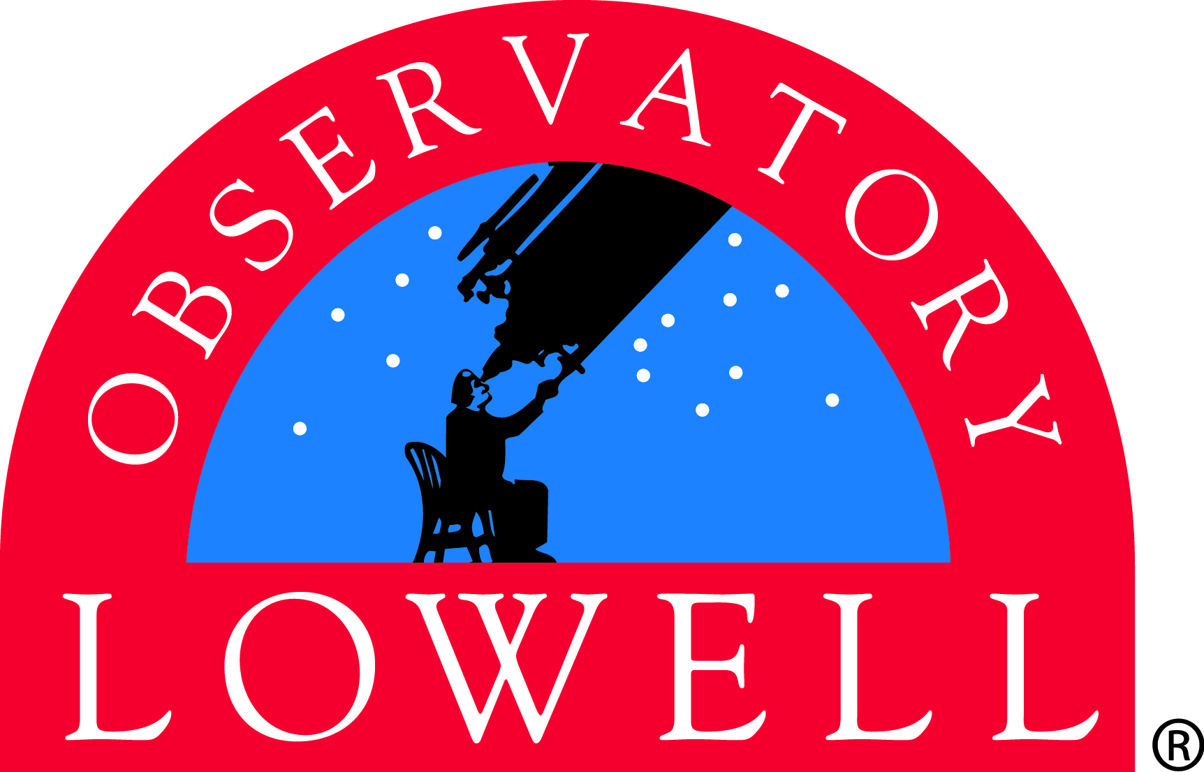

Visiting Scientists Application Form
Please email completed form to mwest@lowell.edu

Name:

E-mail address:

Affiliation:

Position:

Desired dates of visit:

Lowell astronomer(s) with whom the visit has been coordinated:

Purpose of visit and how it will enrich the scientific environment at Lowell:

Tentative title and brief summary of proposed colloquium:

Please indicate what support you are requesting from Lowell Observatory:
- airfare
- accommodations
- per diem
- other ___________________

Have you participated in Lowell’s Visiting Scientists Program before and, if so, when?

Please attach your curriculum vitae and a list of recent publications

